Other-Letter; A hybrid of Sinhala and Tamil scripts for Sri Lanka

- A Work in Progress

Pathum Egodawatta, Graphic Designer, pathumego@gmail.com

Abstract: This paper documents and discusses the development process of a new hybrid script based on Sinhala and Tamil scripts. Sri Lanka has been in a civil war for more than 30 years. Language has been identified as the main reason for the ethnic conflict in Sri Lanka and the post-war reconciliation process has created new issues related to language. An artificial democratic distribution where both communities encounter a sense of otherness has been created with he resettlement of the Sinhalese and Tamil communities in the war-affected areas. Signage and street typography is the spaces where these people encounter the 'other' language. The task was to develop a typographic solution to dissolve the language barrier through these spaces itself. If a single script, writing system and a typeface were developed, based on Sinhala and Tamil, it can be used to write and read by native speakers of both languages. In addition to the development process of the project, this paper briefly discusses the socio-political background, which raised the opportunity for such script.

***Keywords:* Hybrid Script, New Script, Ethnic conflict, New Language**

1. **Introduction**

When two or more languages co-exist in a polity, why does language become the “Object of social and Political conflict”? (Bohem, 1933) In Sri Lanka, the language was the catalyst of the conflict and the 30 yearlong war.

Sinhala and Tamil are the two official languages of Sri Lanka. Sinhala is the most widely used language in the country, used by 74% of the people, while 18% use Tamil. The Tamil and Muslim community whose native language is Tamil, is concentrated at the far northern parts of the island and along the east coast and up-country areas.

The ethnic conflict in Sri Lanka has been traced back to the pre-independence period and language has been recognized as one of the primary catalysts for the war. The armed conflict and terrorism of the LTTE[1] saw an end in 2009, and post-war reconciliation efforts of the government are being heavily criticized of not being effective and honest. To worsen the situation there is a growing distrust between the different ethnicities in the country due to activities of different religious extremist groups. In the post-conflict Sri Lanka, the various reconciliation efforts have been carried out, and the language is something that has been addressed by policy makers, political and social activists and creative community. The history and current situation of the language conflict is discussed in the first half of this paper in order to establish the reasoning behind the project.

1. **Understanding the Ethnic conflict and the role of language in it.**

**2.1. Transformation of language conflict to a territory conflict**

The historical relationship between Sinhalese and Tamil communities was not always agnostic. In the pre-colonial period, there were clear boundaries that differentiated the two communities such as language and scripts, religion, social organization, territorial concentration and sense of collective history (Kearney, 1978). With the introduction of Christianity and English language, the symmetry of the ethnicities was disrupted. Although there were both Sinhala speaking Christians and Tamil Speaking Christians, the Sinhala and Tamil identities were not totally abundant because of Christianity. By the time British left the country in the 1940’s, the historical ethnic symmetry in the country was disturbed.

Under the Portuguese, Dutch and British colonial ruling, the Sinhalese majority came to see them as the subordinate group of the society, in political and socio-economic terms (Dharmadasa, 1981, pp. 47-70). With the departure of the British, the Sinhalese majority tried to connect with the past greatness of the Sinhalese and the language was brought forward as the main identifier of the ethnicity.

In 'A Study of North India', Paul Brass argues that, in particular historical and social context, one ethnic traitor or symbol may be identified as dominant and others as secondary (Brass, 1974). In Sri Lankan context, the spoken language and script language was the dominant symbol among other ethnic traits such as religion. As a result of political gameplay, in 1956 Official Languages Act was passed making Sinhalese the only official language of Sri Lanka.

**2.2. The ‘Sri’ Conflict and 1958 riots**

Incidents led to 1958 riots are clear indication of an space for a typography based solution for language conflict. In 1958 Federal Party launched the ‘anti Sri’ campaign in the North, defacing the Sinhala letter ‘Sri’(›) on vehicle license plates and Sinhala letters on signage and name boards in the North and East with tar. This was direct a reaction to the Sinhala Only bill.

“The government made the situation worse by sending to Jaffna government-owned buses with the Sinhalese symbol denoting ‘Sri’ on number plates; a crazy innovation that provoked Tamil anger. An anti-Sinhala Sri campaign in Jaffna led to the defacing of the Sinhala Sri letter on buses and substituting of the Tamil ‘Sri’ instead. (Sivanayagam, 2005)

Soon the situation ran out of control and there were major out brakes of mob violence against both Sinhala and Tamil in different parts of the country.(Wilson,1988)

This is noted as one of the defining incidents of the Sri Lankan ethnic conflict, as this action led the Tamil community to believe that the actual solution would be to have a territory of their own. A particular language is used by people; people live in an area and a sense that language occupies a territory led became the resolution to the language conflict in Sri Lanka. (Dharmadasa, 1981, pp. 47-70)

1. **Post-war reconciliation and status of the language problem**

In the year 2009, the war was officially declared over by the government of Sri Lanka with the defeat of the LTTE. Since, the rehabilitation and the reconciliation in the country have been criticized internationally. Despite the efforts of the state, the civil society is far from a meaningful harmony. In a study carried out in November 2013[2], 82.2% of Sinhalese believed that Official Language of Sri Lanka is Sinhalese only, and 26.5 of Tamils said that Government of Sri Lanka has done nothing to address the root causes of the conflict.

Although the official languages policy was revised with making Tamil a co official language, implementation of policies for bilingual access haven't been successful. Report of the COMMISSION OF INQUIRY ON LESSONS LEARNT AND RECONCILIATION reports implications of this.

“..The tardiness of Governments in giving effect to its implementation (of 13th Amendment to the Constitution in 1987 that made both Sinhala and Tamil official languages) has further alienated the Tamil people, exacerbating their feelings of marginalization. This has resulted in a perception prevailing among the Tamil people of being second class citizens in their own country.”

(LLRC SL, 2011)

* 1. **Cultural invasion in North and East**

There are accusations of cultural invasion in the areas that have been freed from the LTTE. Northern and eastern parts of the country were under control of LTTE for years, and Tamils are the majority in these areas. Most of these areas are under military control since the defeat of LTTE. Usage of Sinhala language for essential services in these areas, have intimidated the Tamil people. This was noted in the Report of the COMMISSION OF INQUIRY ON LESSONS LEARNT AND RECONCILIATION

“The Commission during its visits to the affected areas witnessed firsthand, that even today many persons of the minority communities are made to transact business, not in the language of their choice.” (LLRC, 2011)

**3.2 Change of demographic distribution and Language invasion**

With the controversial resettlement of the displaced Sinhalese families in Northern and Eastern parts on the island, currently the demographic distribution in these areas is not natural. This situation has created a greater level of tension between the ethnicities. Construction of new Buddhist temples and establishment of Sinhalese companies have made the Sinhala letters and boards appear in wide light in the middle of these previously Tamil concentrated areas.

Many companies and institutions such as banks that recently opened their branches in North recently are using the same advertising and promotional materials, which were produced for Sinhala audience. (Jayasuriya, 2011) So this situation is an invasion of culture to the Tamil community.

1. **A hybrid Script of writing**

The opportunity for a typography based intervention, raised with the ‘appearance of the language’ becoming a vital factor in reconciliation in the Northern and eastern parts of the island. As stated before spark for the 1958 riots was of appearance of language. A similar situation is building up after the defeat of LTTE. Resettled Sinhalese has a deep distrust and tendency to establish power thru language usages such as banners, signage, and displays.

It was observed that the typographic solution that could blur out this otherness would succeed in creating a positive feeling between two ethnicities. It is noted that the rapid development happening in the country would facilitate the implementation of such solutions.

* 1. **Project scope**

This project was focused to combine letters from Sinhala and Tamil scripts that correspond to the same phoneme and construct new letters that could be read by the both Sinhala and Tamil communities. New script could be considered as a constructed script[3].

The common roots of the Sinhala and Tamil languages were examined and identified. The characteristics and aesthetics of both scripts were taken into account, and new script was developed to be neutral without being bias to a single script.

These guidelines were established to streamline the development process.

1. Both writing systems should be simplified preserving the qualities. (ie: Consonant and vowel signifier combination)
2. Preserve the original forms and aesthetics of the letters.
3. Characters should be easy to recognize and this should be evaluated based on following aspects.

i. Legibility

ii. Preserving the original visual aesthetic qualities of the both languages.

iii. Aesthetic harmony of the script.

iv. Always test for readability and legibility (With different demographic segments)

4. For the purpose of study use FM Malithi [4] and Kohinoor Tamil [5] as the reference typefaces for Sinhala and Tamil.

5. Develop the typeface as a Mono-linear.

* 1. **Research methodology**

Each glyph was developed following a combination of following three methods.

* + 1. ***Understanding the basic visual form of each letter.***

Both Sinhala and Tamil scripts belong to the same Brahmic scripts family and few steps back into the historical development of these letters reveal that most of the Sinhala and Tamil letters share a common basic form. (See Figure 1) These basic forms were used as a starting point of development.

Figure 1 illustrates the few stages of development of Sinhala ‘අ’ and Tamil ‘அ’. Form of the letter was identified and then this basic form was manipulated with using the elements from the current status of the letters.

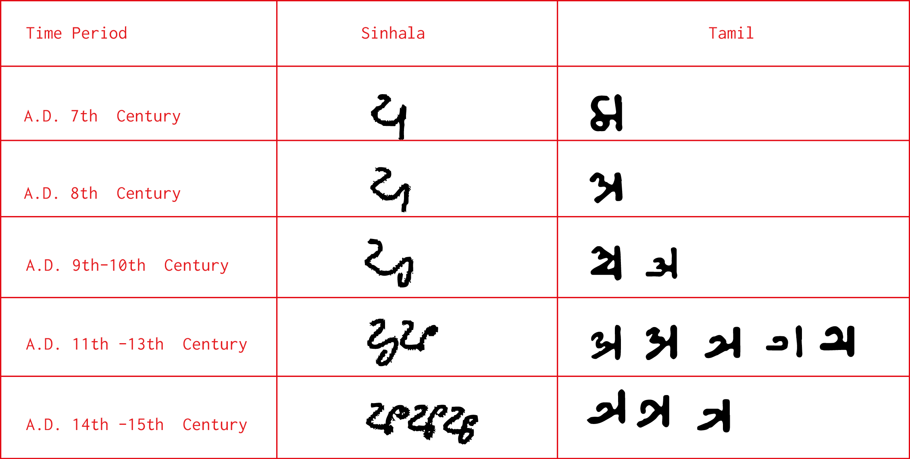

Figure : Historical development of Sinhala ‘අ’ and Tamil ‘அ’

In a few letters, the basic form of both Sinhala and Tamil was close enough to identify the common form right away. Figure 2 presents the side by side comparison of ‘u’ (උ , உ) 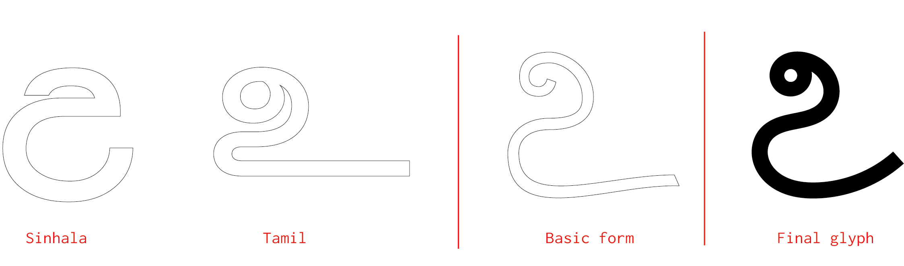

Figure : Basic form identified thru historical developemnt.

* + 1. ***Identifying similar elements of corresponding letters***

There are obvious similarities between the Sinhala and Tamil scripts due to the common roots. The Figure 3 illustrates the first step to identify these similarities between the corresponding letters. Two glyphs were overprinted on each other to be able to identify the similar elements.

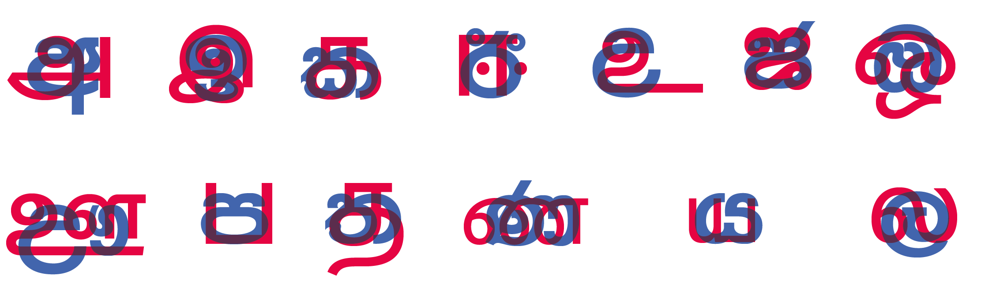

Figure : Overprinting corresponding letters.

Next step was to construct letters based on the similar elements.

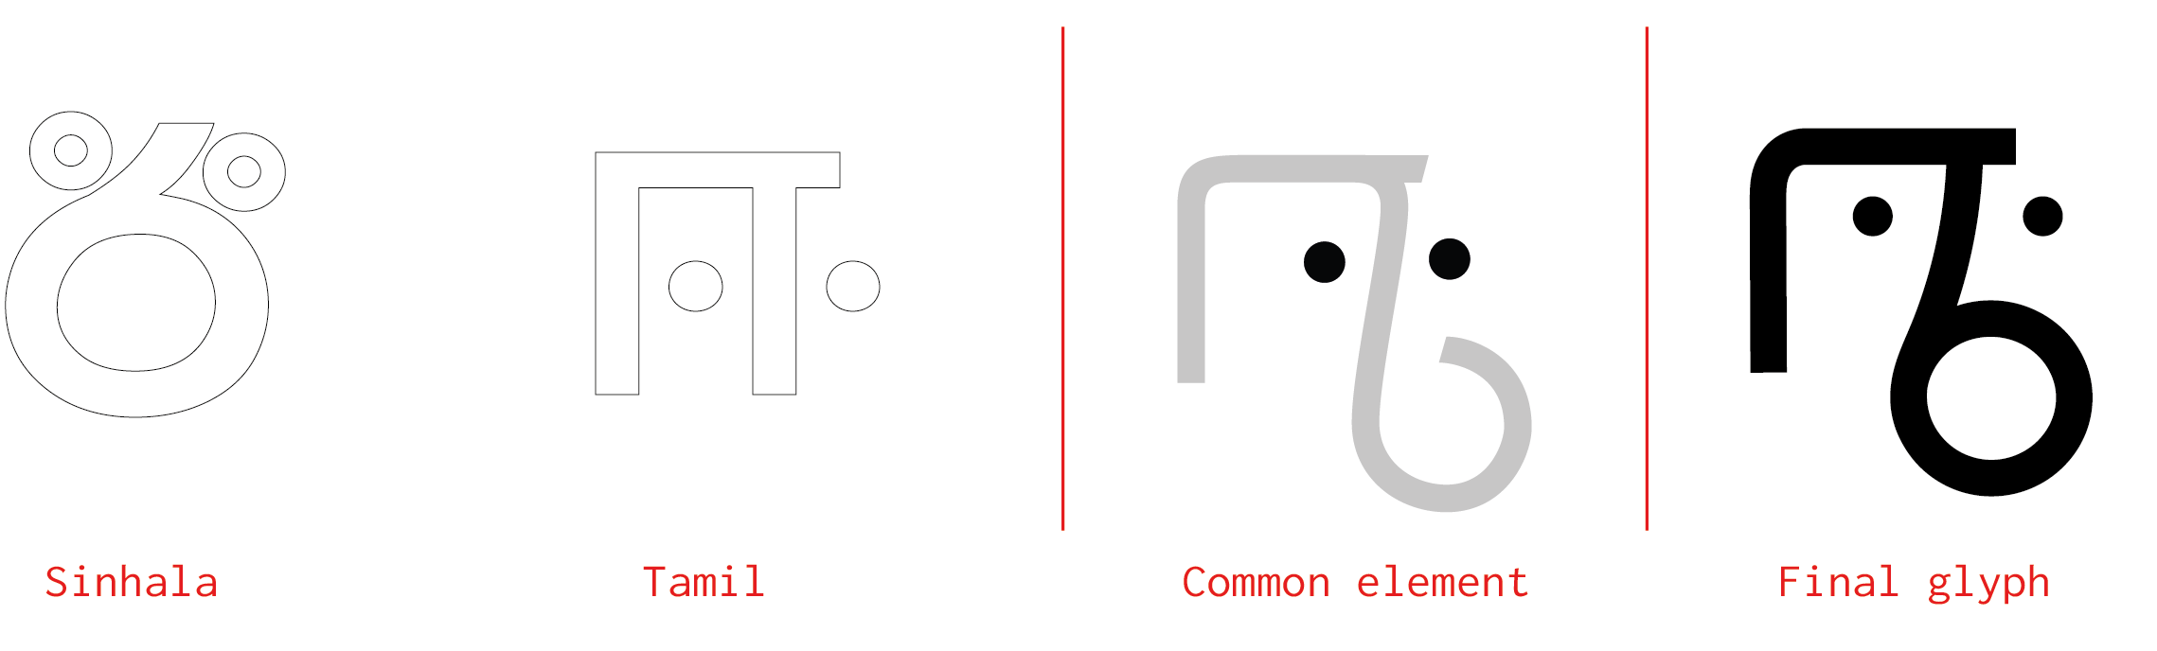

Figure : Identifying the similar elements and using those elements to construct a letter.

**4.2.3 Identifying most significant element of each Tamil and Sinhala letter**

Apart from the basic form and shape of a letter, there was a significant element to each letter. In some corresponding Sinhala and Tamil letters, these significant elements were the only thing that set apart the two letters. (See the Figure 5)

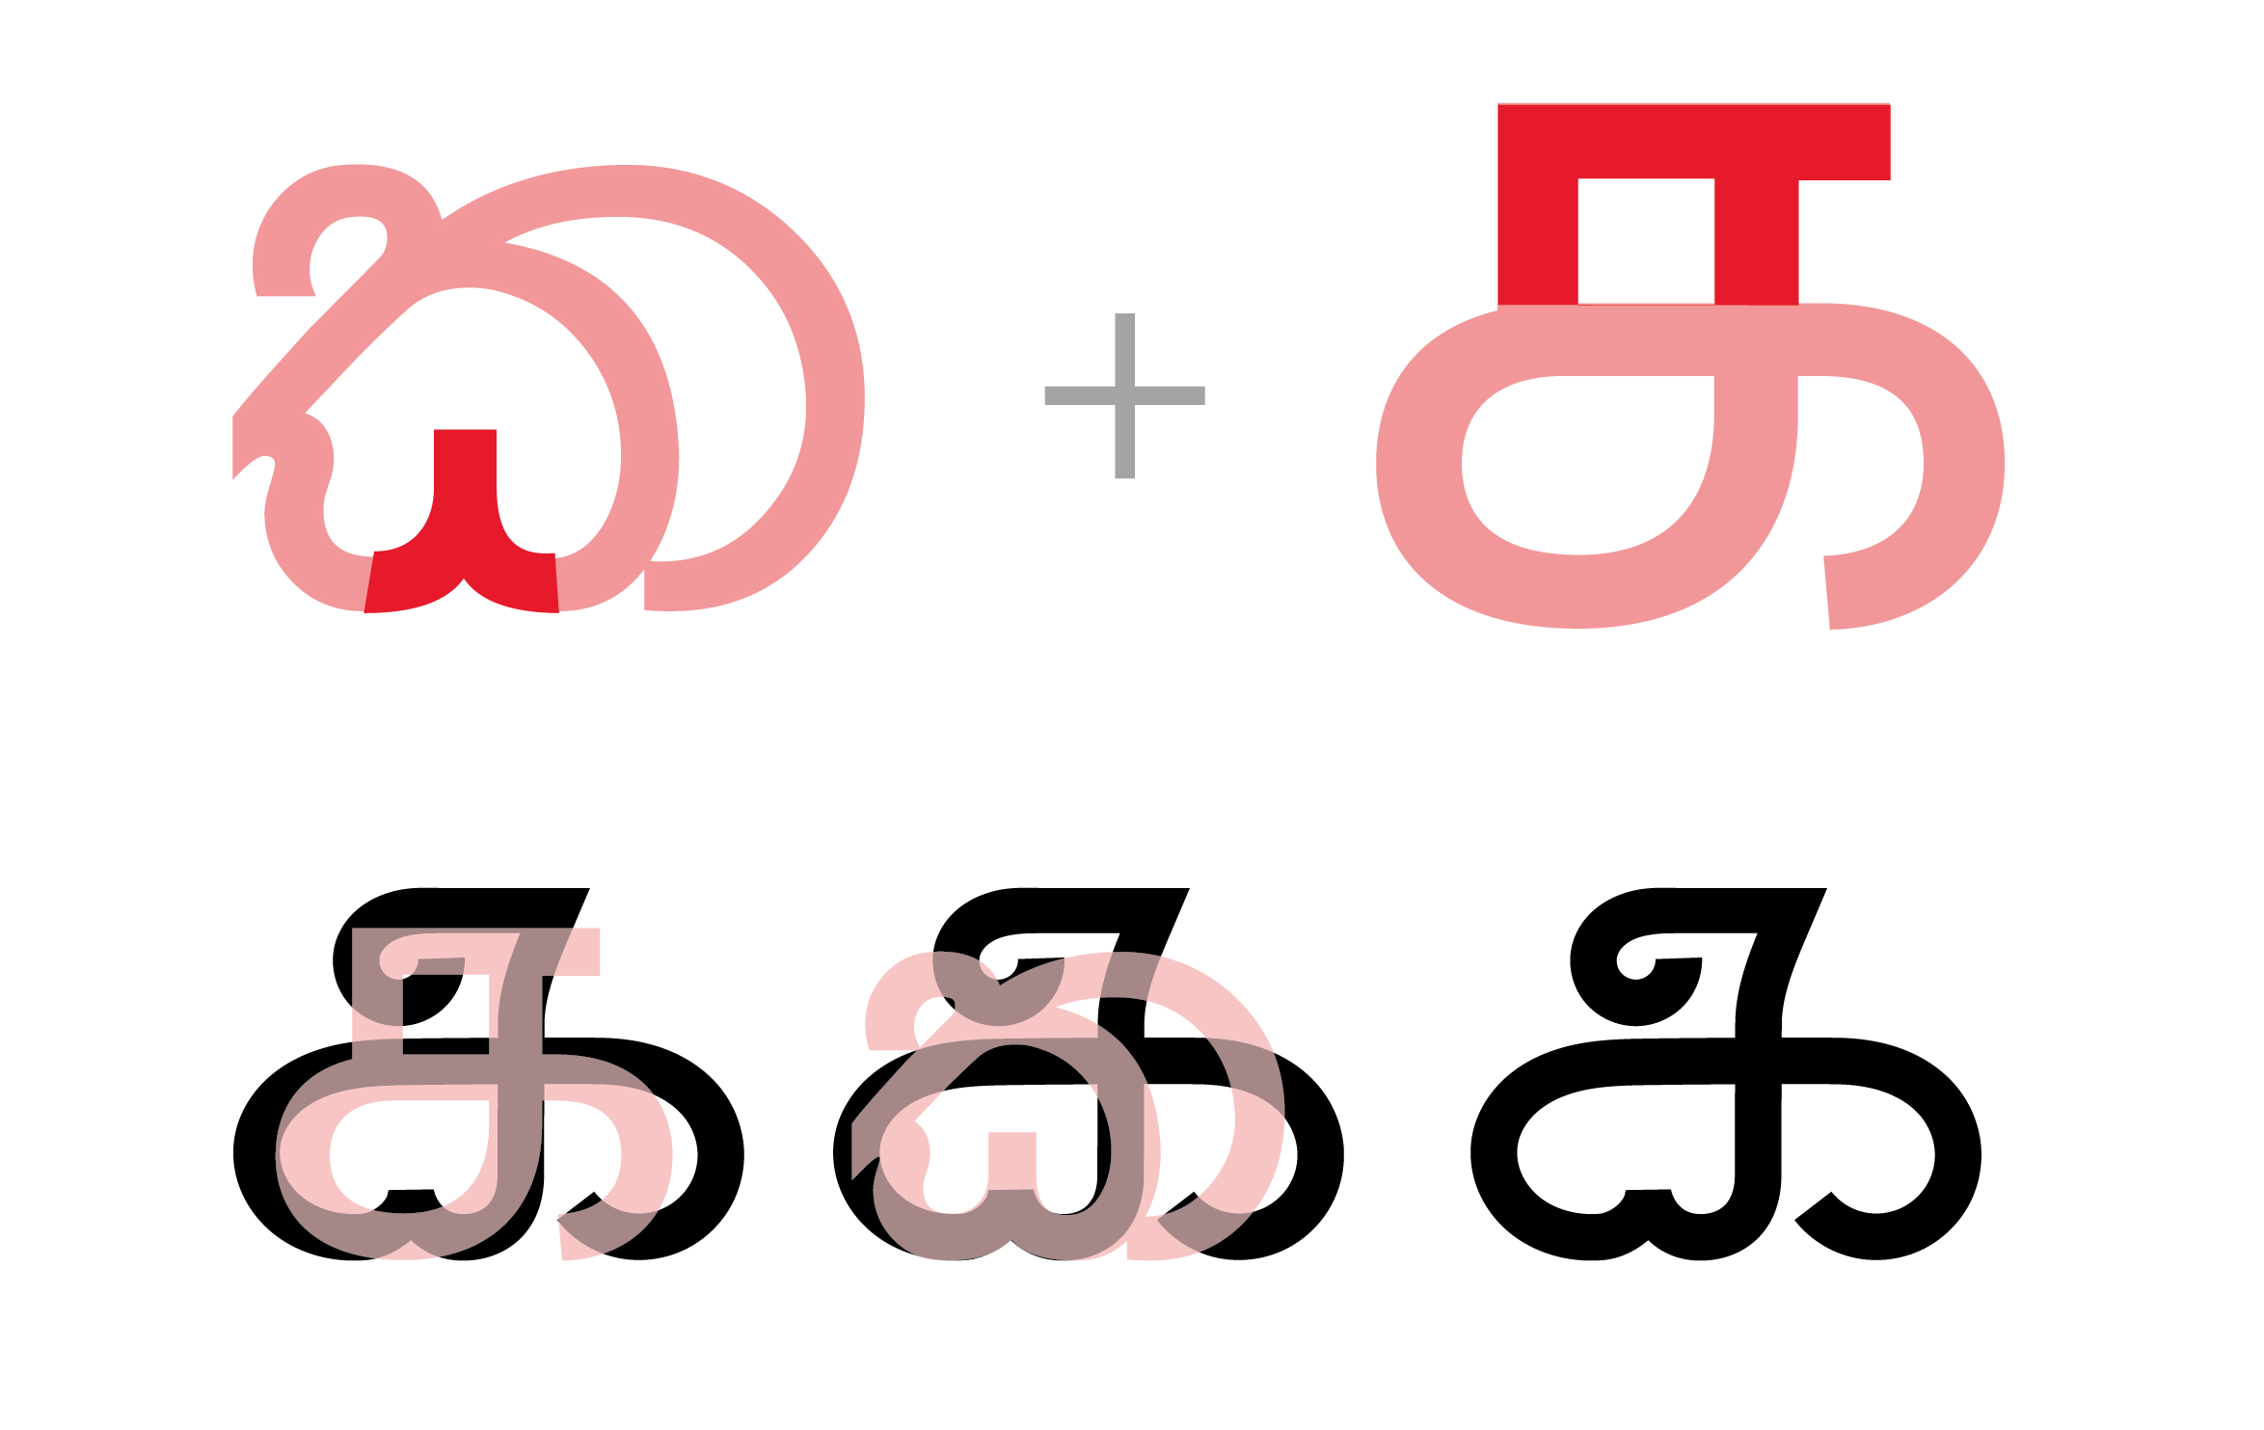

Figure : Combining the significant elements to the basic form

**4.3 Development of the grid**

The new script required a new set of guidelines in order to maintain the structural integrity and aesthetic of the characters. In this case, the grid system was essential due to the hybrid nature of the script. Unfortunately, the lack of literature on the anatomy of Sinhala letters was a downside during this exercise. The baseline, ascender height and the descender height was developed based on two different heights, benchmarked from reference typefaces.

The positioning of the letters was the most crucial element in regard to legibility. During user testing, it was observed that legibility would dramatically vary, based on the positioning of the letter. Both Sinhala and Tamil both scripts have ascending, descending and mid letters, and positioning of the combined letters had to be carefully determined based on the user testing results.

Figure 6 illustrates the development of the corresponding letter to phoneme (r). Sinhala ‘ර’ is a ascending letter and Tamil ‘ர’ is descending letter. The two letters are almost vertically flipped versions of each other. Due to this difference of position, the grid was developed double lined. 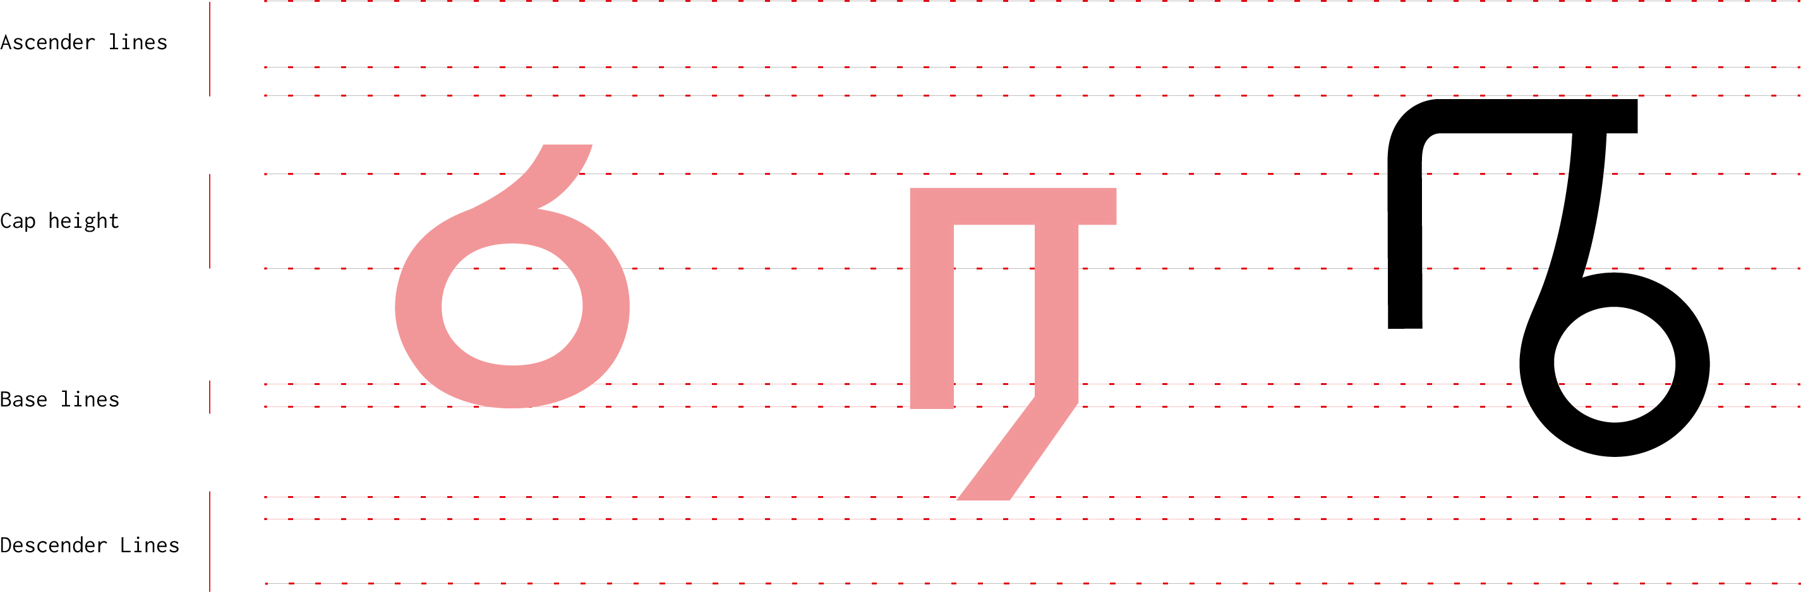

Figure : Grid developed for Other-Letter

Although this grid was used as a basic tool fro development. For the sake of legibility, the positioning of the each letter combination should be carefully adjusted based on the adjoining letters the same way the kerning adjusted.

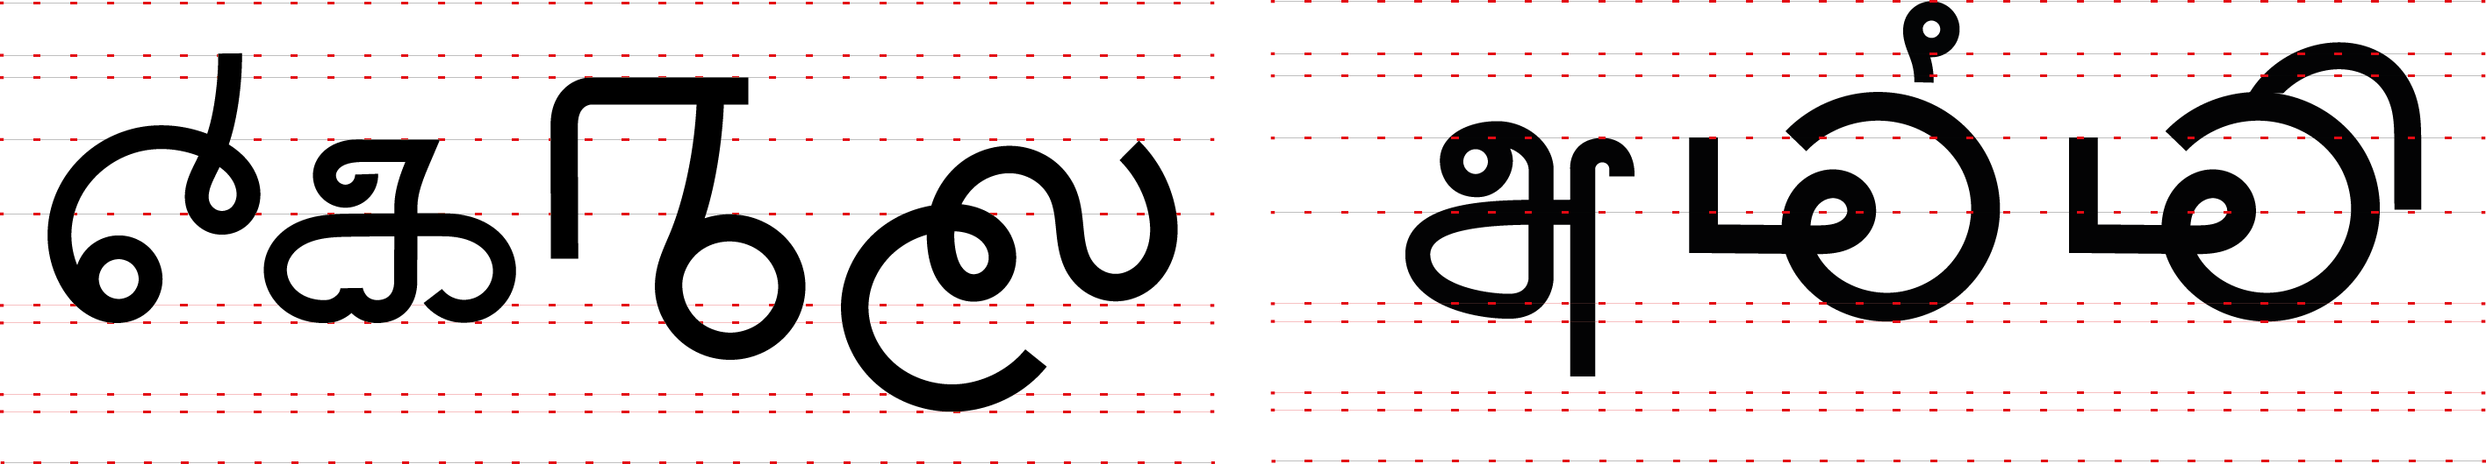

Figure 7: Different glyphs on the grid

* 1. **Unification of writing systems and diacritics**

Both Sinhala and Tamil are abugidas[6] and addition of vowel modifiers (diacritics) has many common features. Most of these diacritics have similar visual forms and positioning. Figure 7 is illustrates the consonant 'k' as an example.

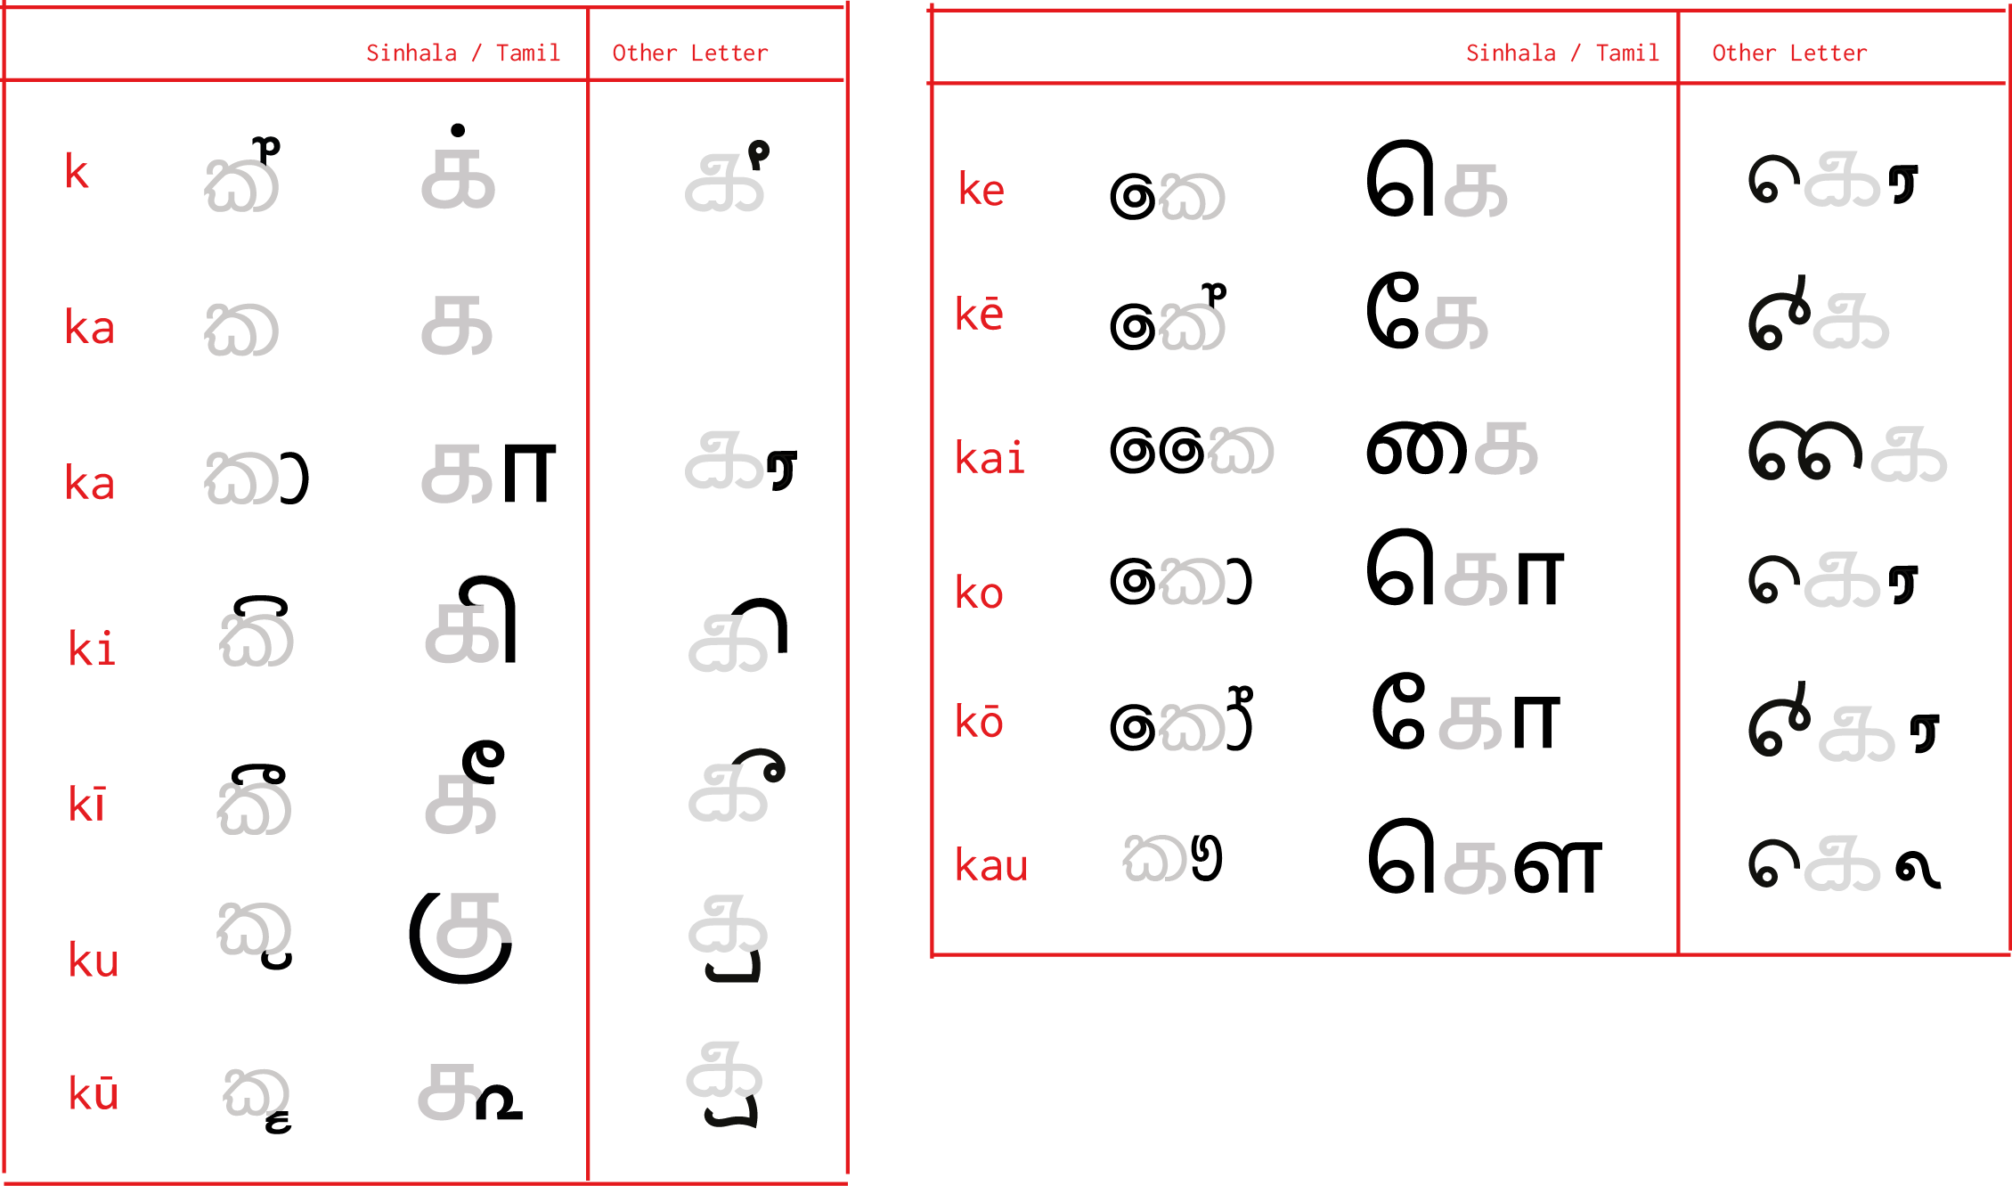

Figure : Development of diacritics

For the first phase of the project, it was decided to develop the vowel modifier glyphs separately. In further development, separate glyphs with consonant + modifier glyphs that take non-standard forms could be developed to make this script more legible.

* 1. **Simplifications of alphabets**

Assuming that this new script would be adapted into real life scenarios, it was necessary to maintain the simplicity of the script.

The Sinhalese alphabet is divided into two sets, Pure letters ( śuddha Sinhala ) and Mixed Sinhala (Miśra Sinhala) letters. Although most phonemes of the Sinhalese can be represented using a śuddha letter or a Miśra letter, in standards only of them is considered correct. For example, both න and ණ represents the phoneme ‘na’. Sinhalese has 10 aspirate letters, but Tamil has none. Tamil also has one-to-many phoneme-grapheme system. Simplification of this system to a one-to-one phoneme- grapheme assigned system was needed, to make it easy to understand, learn and read.

Also Sinhala has a relatively complex system of vowel modifiers. Based on the position of the letters consonants, (i.e. ක, ර and ළ), take non-standard forms when it is added with a vowel modifier. This scenario of non-standard forms is demonstrated in the Figure 9.

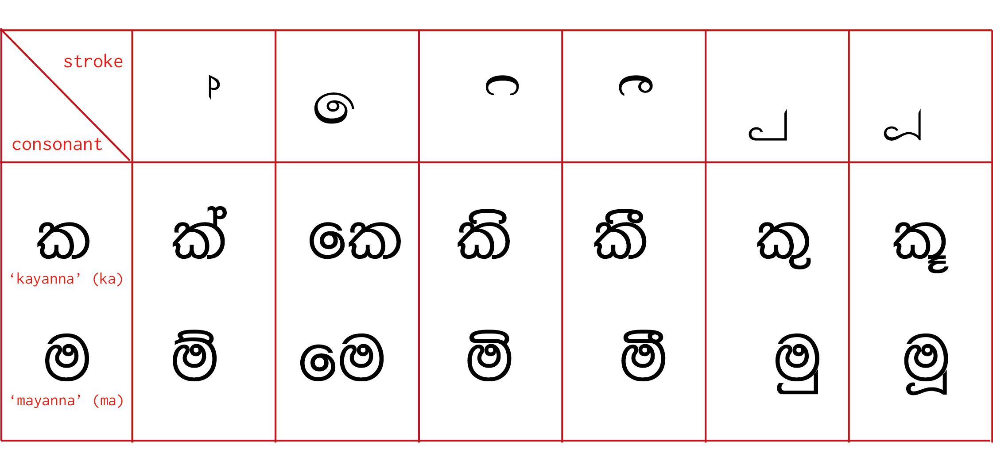

Figure : Different schemes of Sinhala vowel modifiers

Various reforms to Sinhala script and language have been proposed aiming to simplify and to make it more accessible. Reforms suggested by Ajith Thilakasena, an award-winning author, has been followed by many other authors. This system excluded the aspirate letters and other complex diacritic systems. Although it is far from being implemented, it is the most comprehensive simplified version of Sinhala script. This system was benchmarked to construct the new writing system.

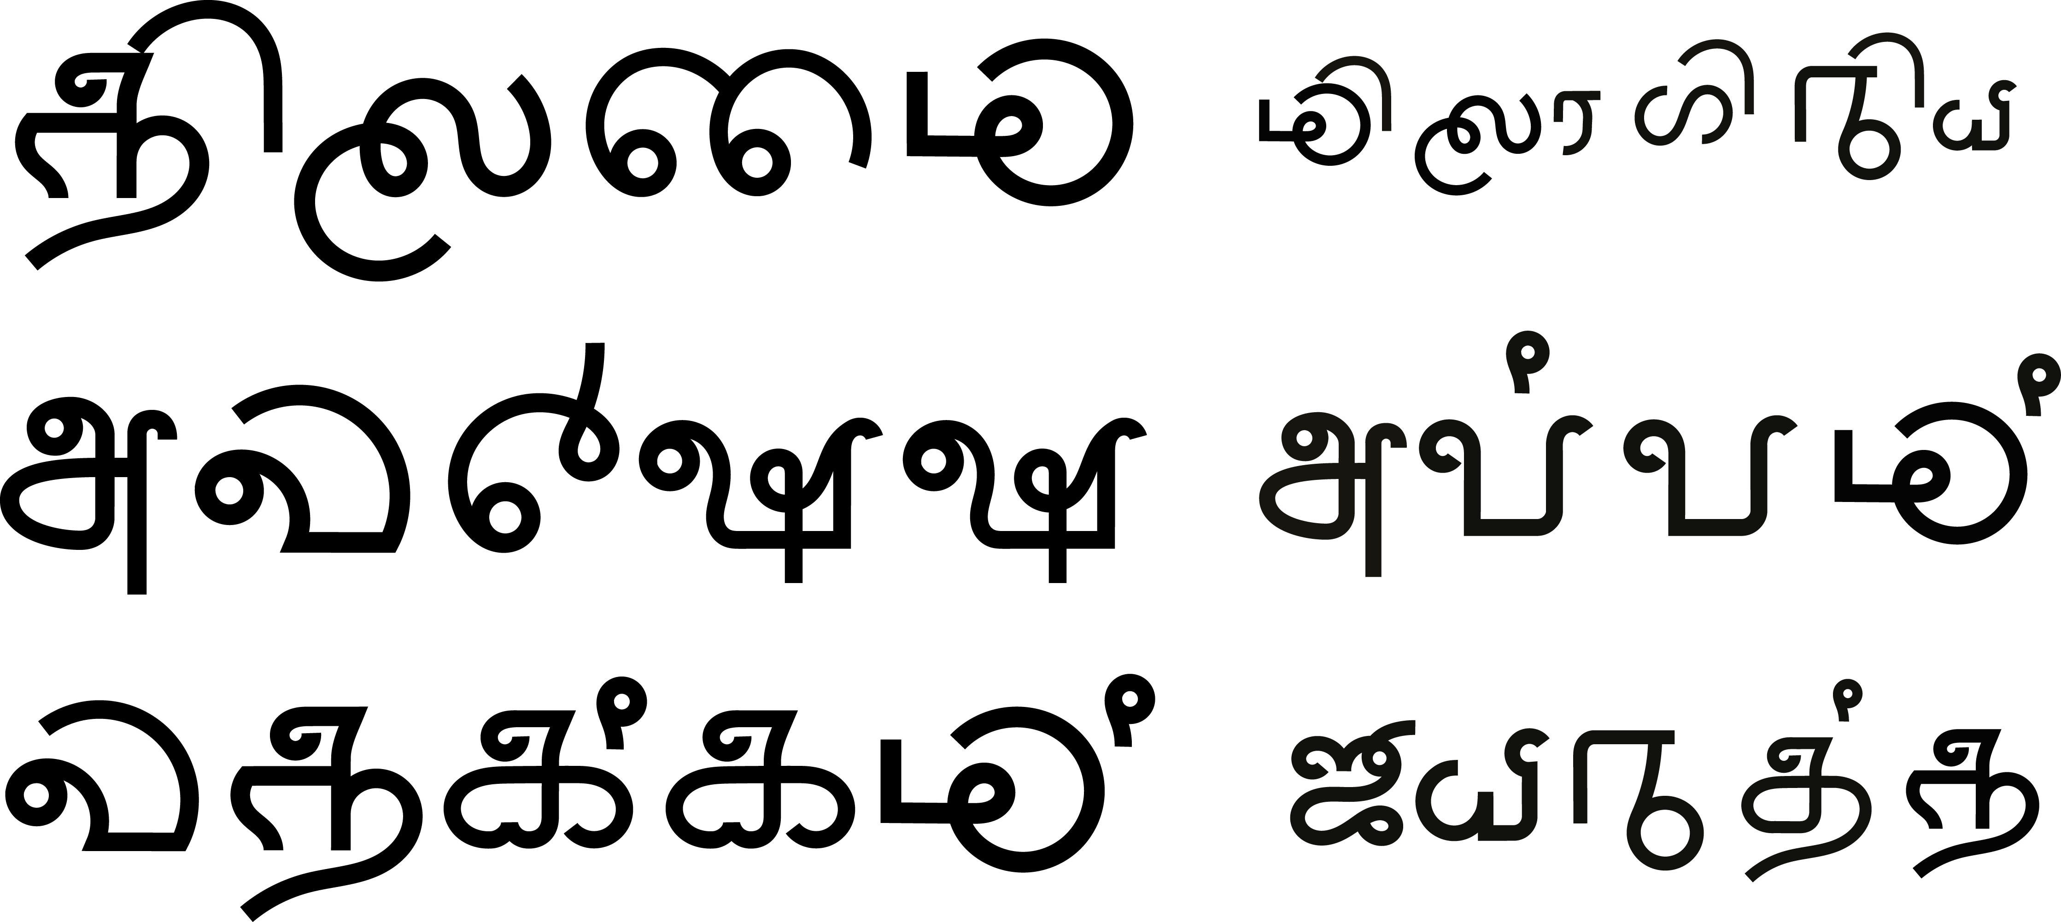

Figure : Different words written with Other- Letter script

1. **Further Applications of the script**

Main user case for this system is signage and way-finding. For way-finding, this

script could replace the traditional trilingual boards. (See Figure 11)

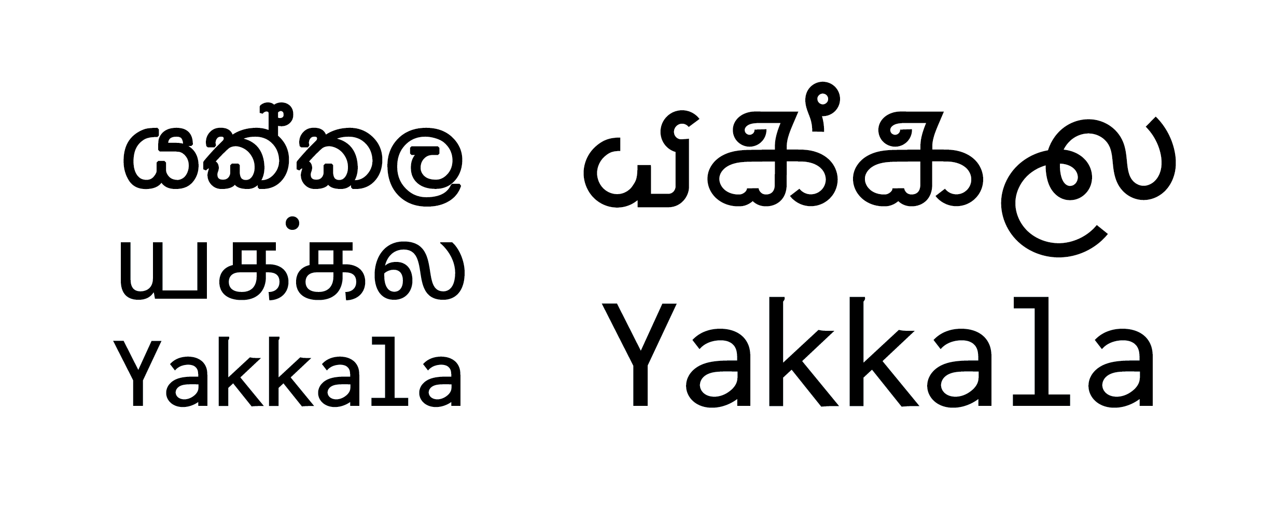

Figure : Conventional trilingual signage in railway stations replaced with Other-Letter

Figure 11: Conventional trilingual signage in railway stations replaced with Other-Letter

Another possible application is product names and logos to make it more familiar to people. Thriposha, the free nutrition cereal from the government, has the name in Sinhala letters arranged as a logotype. This is the most widely distributed early childhood nutritional pack in the country. Figure 12 the name is replaced with Other-Letter script to make the logotype readable by the both Sinhala and Tamil people.

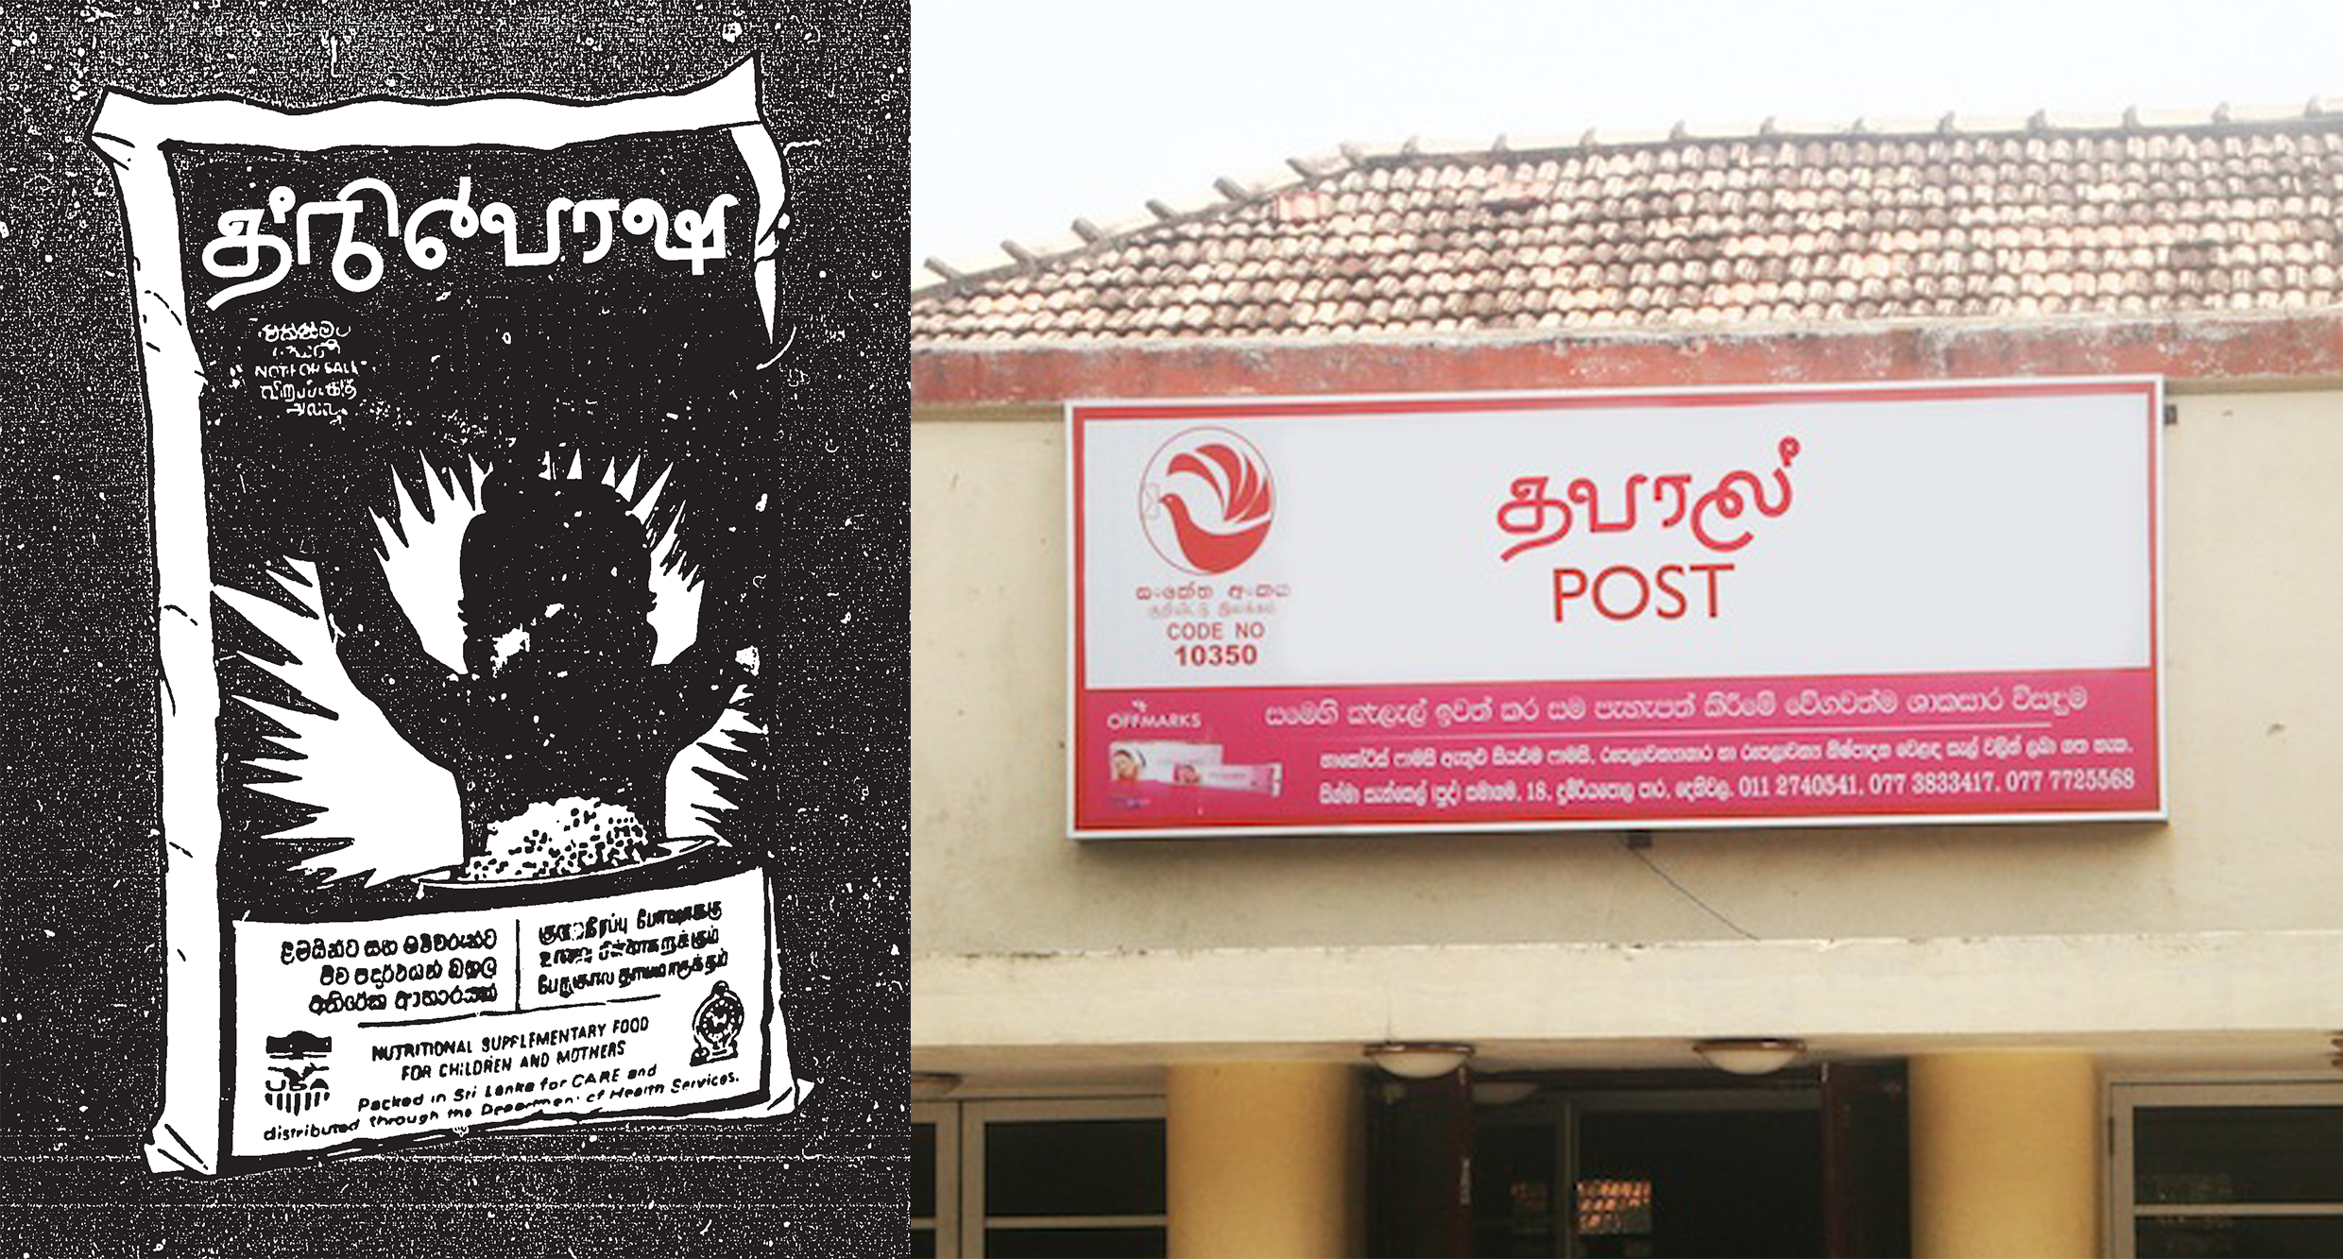

Figure : Other-letter used in different contexts: Left- Thriposha, a nutritional cereal distributed free by the government. Right – Post Office Sign

Although this script could be used to write in Sinhalese or Tamil, it will only be understandable to someone who is fluent in the language it’s written. However in a scenario where a Sinhala word and Tamil word share the same meaning and the same pronunciation, it would be understandable to anybody. Sinhala has more than 200 identified loanwords with Tamil origins and many other common words which were borrowed from Portuguese. (Coperahewa and Arunachalam, 2002) These words could be written in this script. For example words ‘අම්මා’ in Sinhala and ‘அம்மா’ in Tamil, that means Mother, is pronounced ‘ammā’ in both languages.

Figure 13 presents few different type sample sketches based on the Other-Letter script. This is an example of how this script could be adapted highly stylized type usage. Other-Letter can be used in different contexts with a relevant style and still be legible, regardless of the hybrid nature.

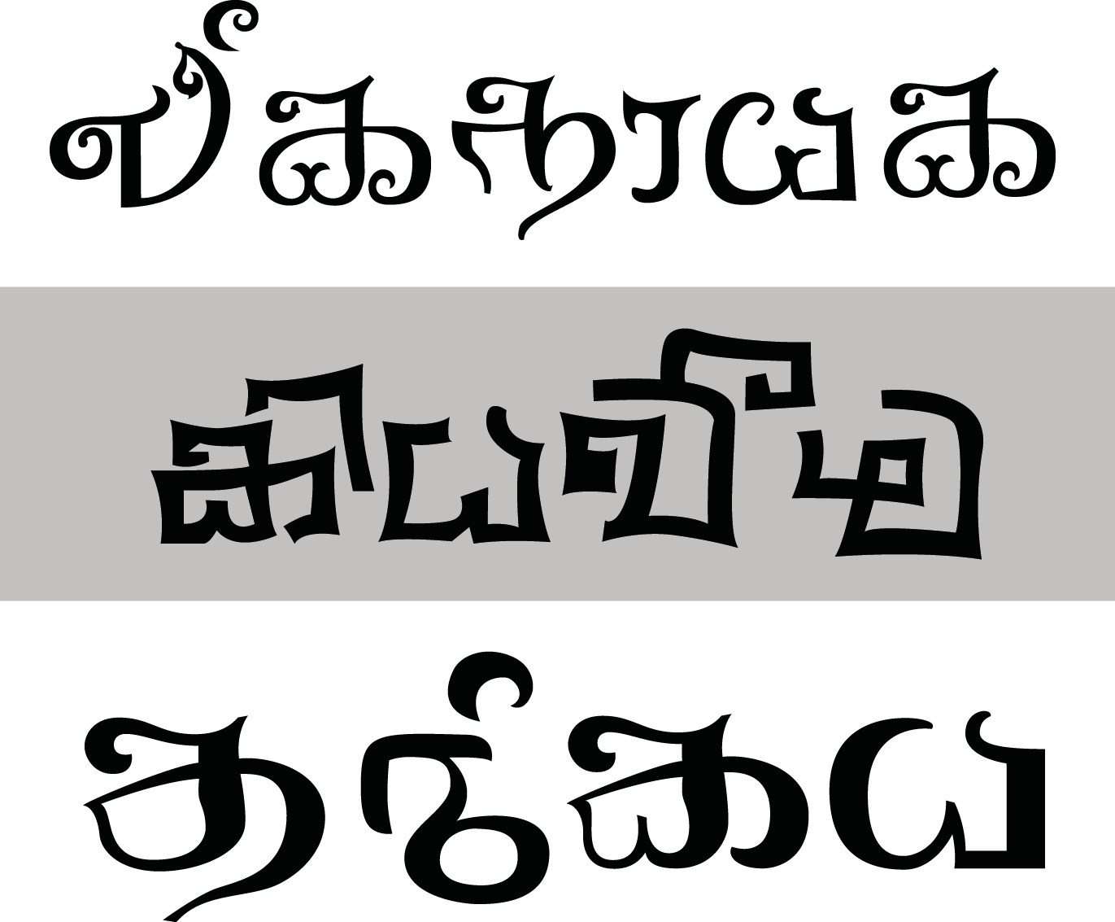

Figure : Type sample sketches by Pushpananda Ekanayke[7], based on Other Letter.

**6. Conclusion**

The language and the script it’s written with is an important signifier of the culture and people it belongs to. Sri Lankan community is undergoing a culturally challenging situation where the division amongst the different communities is getting wider every day and language has been the dividing factor. This paper examined the possibilities of utilizing the knowledge of typography and design practice to propose a viable solution to a specific issue related to this situation.

By combining Sinhala and Tamil letters into one script, the basic ethnic signifier - language - that defined the divide among the Sinhalese and Tamils, giving it a new meaning. Can typography redefine and solve a conflict that caused a 30 yearlong war? No, this project is about dissolving the language barrier - the most basic division between these two communities.

This is a work in progress See the full project at <http://lankatypeproject.com/>

**References**

***Books***

Brass, P. R. 1974. Language, religion and politics in North India. London: Cambridge University Press.

Wilson, D. J. 1988. The Break-up of Sri Lanka: The Sinhalese-Tamil Conflict. London: C.Hurst & Company.

GUNASEKERA, R. G. G. O., SAMARASINGHE, S. G., VAMADEVAN, M., & DHARMADĀSA, K. E. O. 1996. National language policy in Sri Lanka, 1956 to 1996: three studies in its implementation. Kandy, Sri Lanka, International Centre for Ethnic Studies.

Department of Census and Statistics, Sri Lanka. 2001. Census of Population and Housing 2001. [report] Colombo, Sri Lanka: Department of Census and Statistics, Sri Lanka.

Coperahewa, S. and Arunachalam, S. 2002. Sinhala Bhashave Demala Vacana Akaradiya (A Dictionary of Tamil Words in Sinhala). Colombo, Sri Lanka: Godage.

Tilakasēna, A. 1997. Adata obina basa. Colombo: Goḍagē saha Sahōdarayō.(Original text in Sinhalese)

Disanayaka J. B. 2000, Letters and Strokes, S. Godage

Presidential Task Force for a Trilingual Sri Lanka, 2012,[Draft] Sinhala Letters, Presidential Task Force for a Trilingual Sri Lanka

S. Sivanayagam,2005,Witness to History: A Journalist’s Memoirs (1930- 2004)

Vittachi, T. 1958. Emergency '58. [London]: Andre Deutsch.

Top of Form

Bottom of Form

Roberts, M. 1994. Exploring confrontation. Chur, Switzerland: Harwood Academic Publishers.

**Journals**

Dharmadasa, K. 1981. Language conflict in Sri Lanka. Sri Lanka Journal of Social Science, 4 (2), pp. 47-70. Available at: http://dl.nsf.ac.lk/handle/1/4948 [Accessed: 12 Jan 2014].

Kearney, R. N. 1978. Language and the rise of Tamil separatism in Sri Lanka. Asian Survey, 18 (5), pp. 521--534.

Brown, W. N. 1953. Script reform in modern India, Pakistan, and Ceylon. Journal of the American Oriental Society, 73 (1), pp. 1--6.

***Electronic Sources***

Razak, I. 2012. Sri Lanka Ethnic Conflict: Past And Future. [online] 30th June. Available at: https://www.colombotelegraph.com/index.php/sri-lanka-ethnic-conflict-past-and-future/ [Accessed: 15 Jan 2014].

Jayasuriya, R. 2011. Sinhalaisation of the Tamil North amidst increased militarisation. Trans Currents, [blog] 4 June 2011, Available at:http://transcurrents.com/news-views/archives/1077 [Accessed: 16 Jan 2014].

Danielson, J. 2013. The Art and Science of Constructed Scripts. [video online] Available at: http://www.youtube.com/watch?v=PSL106ZG-v4 [Accessed: 10 Jan 2014].

***Reports***

Social Indicator, Centre for Policy Alternatives - Sri Lanka. 2013. Top line survey results: Democracy in post-war Sri Lanka. [report] Colombo, Sri Lanka: Centre for Policy Alternatives - Sri Lanka.

COMMISSION OF INQUIRY ON LESSONS LEARNT AND RECONCILIATION. 2011. Report of the COMMISSION OF INQUIRY ON LESSONS LEARNT AND RECONCILIATION. [report] Colombo, Sri Lanka: Presidential Secretariat, Sri Lanka, pp. 308 -309.

1. The Liberation Tigers of Tamil Eelam was a separatist militant organization that was based in Sri Lanka.
2. Social Indicator, Centre for Policy Alternatives - Sri Lanka. 2013. Top line survey results: Democracy in post-war Sri Lanka. [report] Colombo, Sri Lanka: Centre for Policy Alternatives - Sri Lanka.
3. A constructed script is a new writing system specifically created by an individual or group, rather than having evolved as part of a language or culture like a natural script.
4. FM Malithi is a typeface by Pushpanada Ekanayake (isiwara.lk)
5. Kohinoor Tamil is a font-family by The Indian Type Foundry
6. An abugida , also called an alphasyllabary, is a segmental writing system in which consonant–vowel sequences are written as a unit: each unit is based on a consonant letter, and vowel notation is secondary.
7. Pushpananda Ekanayake, a renowned type designer from Sri Lanka was given the basic set of letters and was asked to develop type samples.